1. Download release version MagentoV2

<https://github.com/indodana/paylater-ecommerce-plugin-php/releases>

1. Extract
2. Copy plugin/app/ to <magento root>/app/
3. Set folder Acces Permission

cd <magento_root>

find var generated vendor pub/static pub/media app/etc -type f -exec chmod u+w {} +

find var generated vendor pub/static pub/media app/etc -type d -exec chmod u+w {} +

chmod u+x bin/magento

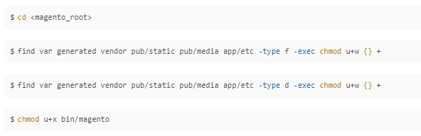

1. Pastikan apache/ngix punya hak write
2. Run <magento_root>$sudo bin/magento setup:upgrade
3. Run <magento_root>$sudo bin/magento module:enable Indodana_PayLater
4. Run <magento_root>$sudo bin/magento setup:upgrade
5. Jika mode developer skip bagian ini ( coba skip dulu )

Run <magento_root>$sudo bin/magento setup:di:compile

1. Run <magento_root>$sudo bin/magento setup:static-content:deploy –f
2. Pastikan apache/ngix punya hak write

Atau mudahnya jalankan

sudo chown -R ubuntu:www-data <magento_root>

contoh

sudo chown -R ubuntu:www-data /var/www/magento/

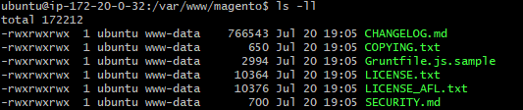

1. Tes magento web